**30 Questions about the Comics Art Museum**

*Expert level*

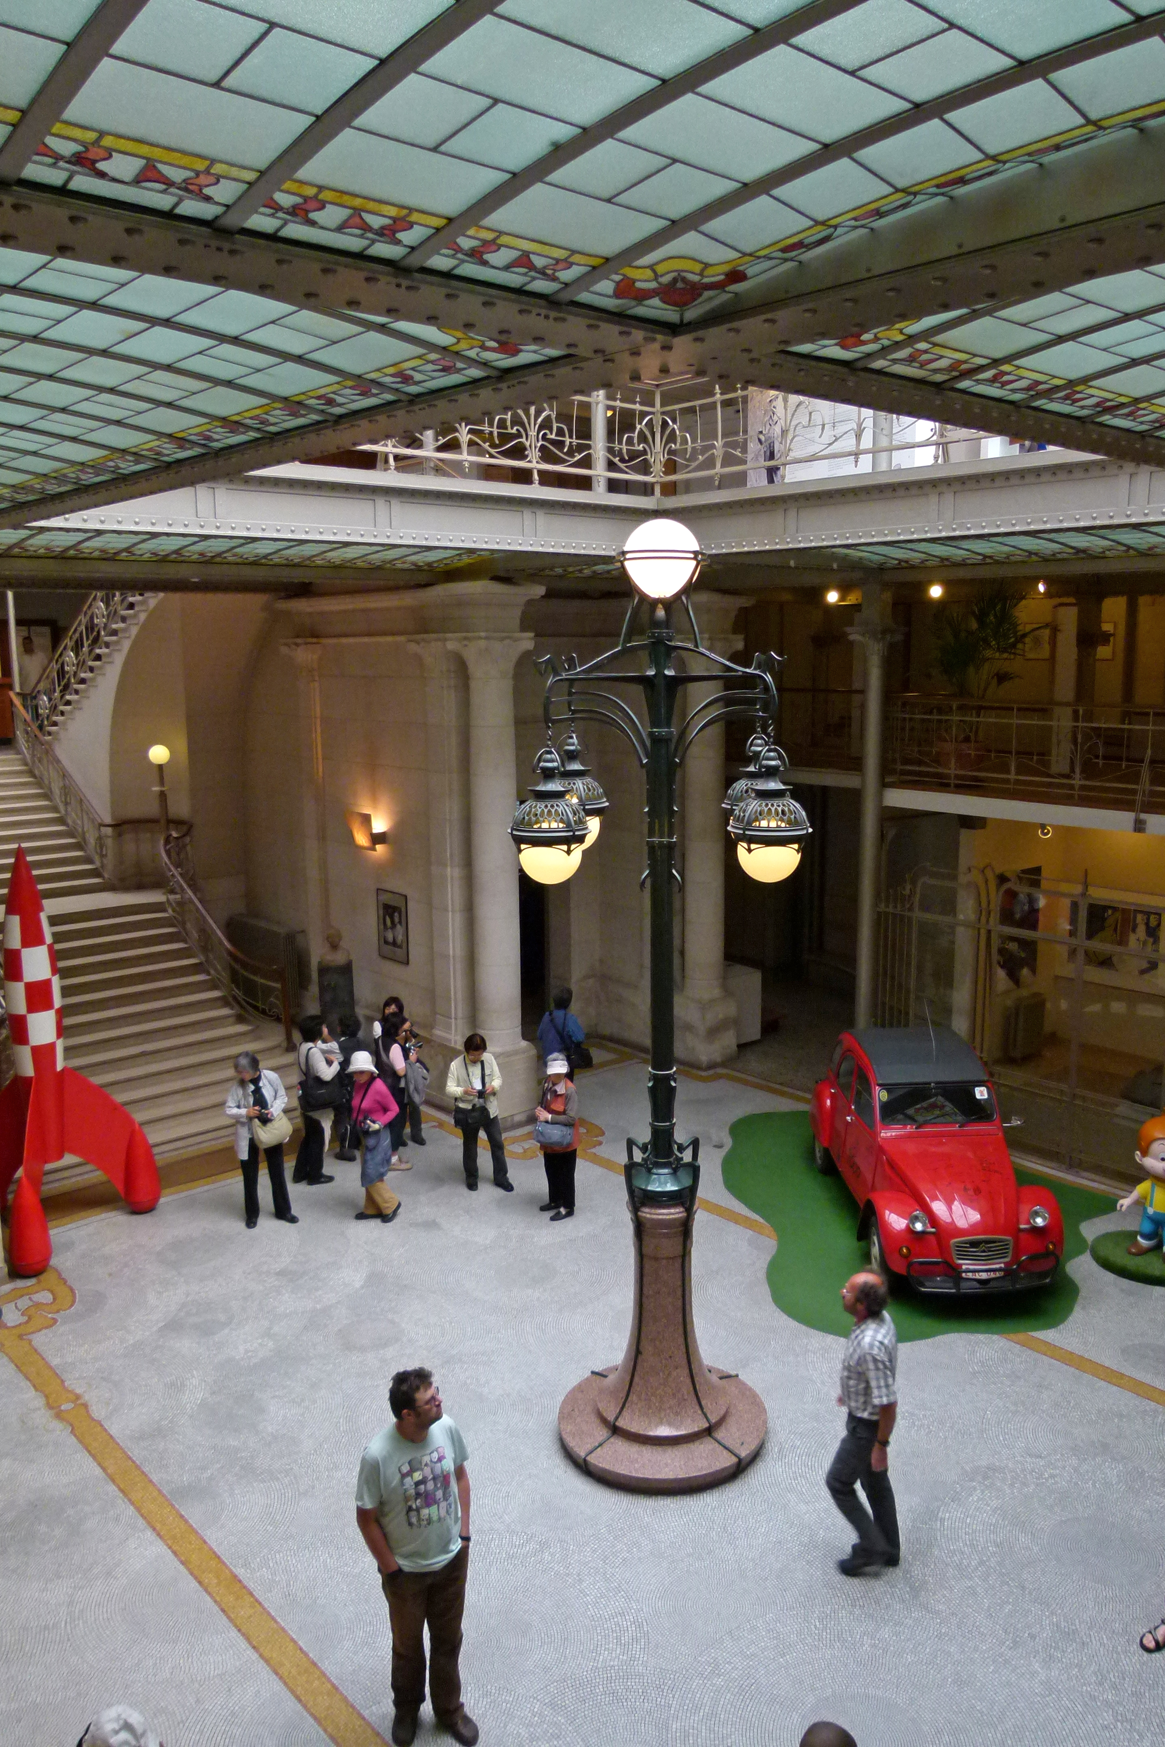**A resplendent building**

1. What was the function of the building situated at number 20 Rue des Sables before Victor Horta built the famous Waucquez warehouse, approximately on the same location?

 a merchant’s guilt house  a hospital

 a refuge  a church

1. What is the name of the specific architectural style of the Waucquez Warehouse, typical for Brussels?

 Bauhaus  Neuhaus

 Art Nouveau  Art Déco

1. During which historical period did the building now used as Comics Art Museum house the prestigious Waucquez warehouse?

 1871-1965  1906-1965

 1902-1989  1905-1983

1. Horta was one of Brussel’s most prolific and successful architects around the turn of the century. Moreover, he knew several stylistic periods, since he never stopped experimenting in his designs. Which one of the following buildings, shown in the same order on the pictures below, was *not* constructed under his supervision?

 Maison du Peuple / Brussels Volkshuis (Brussels People’s House)  Brussel’s Central Station

 Palais des Beaux-Arts (Palace of Fine Arts), Brussels

Old England Warehouse (now Musical Instruments Museum), Brussels

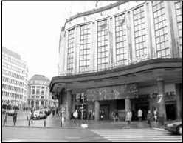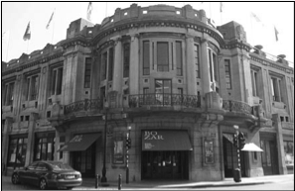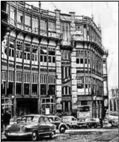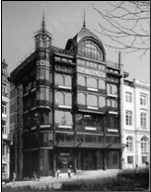

**The origins of the Comic Strip Art**

1. In the first exhibition about the Invention of Comics Art, you will find images and information about the precursors of comic books. As you walk along the screens and panels, you’ll note some of the characters listed below. Connect them to their names and creators.

**Rodolphe Töpffer** **Charles H. Ross & Marie Duval Winsor Mc Cay**

**Richard Outcault** **Pieter de Poortere**

Ally Sloper

Little Nemo

Monsieur Vieux-Bois

Dickie

Yellow Kid

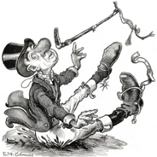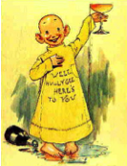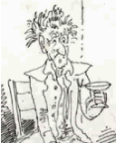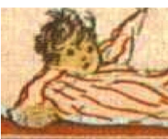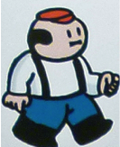

1. What is the main theme of the comic series ‘Little Nemo in Slumberland’?

 fairy tales  the dreams of a little boy

 adventures of a little fish  hallucinations of walking beds

1. Katsushika Hokusai used a Japanese word to designate his spontaneous sketches of everyday life. This word would become the common name for an entire tradition of Asian comic strip. Which of these words are we talking about?

 naruto  wasahari

 anime  manga

1. The press had a significant importance in the comic strip's evolution, especially through political cartoons and caricatures. Look for the drawing of an earth globe being sliced up into pieces. Which nationality are the characters that are dividing the world between them?

 Spanish and Portuguese  French and Spanish

 English and French  English and Spanish

**Original Creators**

1. Every comic strip artist has its own way to make his original artwork. At the very beginning of the Art of Comic Strips exhibition, you can watch a video showing the artist Yslaire at work. This artist adopted a new technique during the last couple of years. Which one?

 direct colouring with watercolour painting  direct colouring with oil painting

 black and white drawings  100% digital drawings

1. It is often necessary to alter or correct the drawings during the creative process of a comic book. Some original drawings of the series “Amoras” by Charel Cambré and Marc Legendre are displayed in the first showcase of the Art of Comic Strip exhibition. What difference(s) can you see when you compare the inked drawings to the final print?

 two panels have been inverted

 one speech bubble has been deleted

 Spike's facial expression changes

 two comic's panels have been inverted and Spike's facial expression changes

1. In the Horta and the Waucquez Warehouse exhibition, two original drawings, displayed side by side, have been produced by two former chairmen of the Management Board of the Belgian Comic Strip Center association. Who are these artists?

 Ferry & Bob De Moor  Frank Pé & Jean-Pol

 Jan Bosschaert & Dany  François Schuiten & Bernard Hislaire

1. Which is the third volume of the series by Kristof Spaey : ‘And if…’, ‘Ever…’ ?

 Once…  A day…

 Never…  Still…

1. The Comics Art Museum collects and preserves accomplished original drawings, but also a lot of research material and preliminary works that show the creation process. In the showcase dedicated to René Follet, which type of document is not being displayed?

a blueprint technique page  a preliminary pencil sketch

 a transparent colouring film  a Leonardo blue film

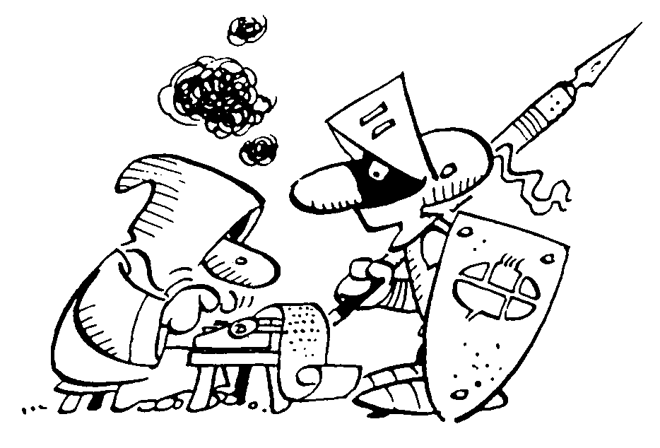

1. Which steps of the production process of the Tintin series were managed by Hergé personally?

 the writing of the scenarios

 the drawings

 the supervision of the studio of drawing artists, writers and colorists and their assistants

**** all of the before mentioned



**World-class heroes from a small country**

1. 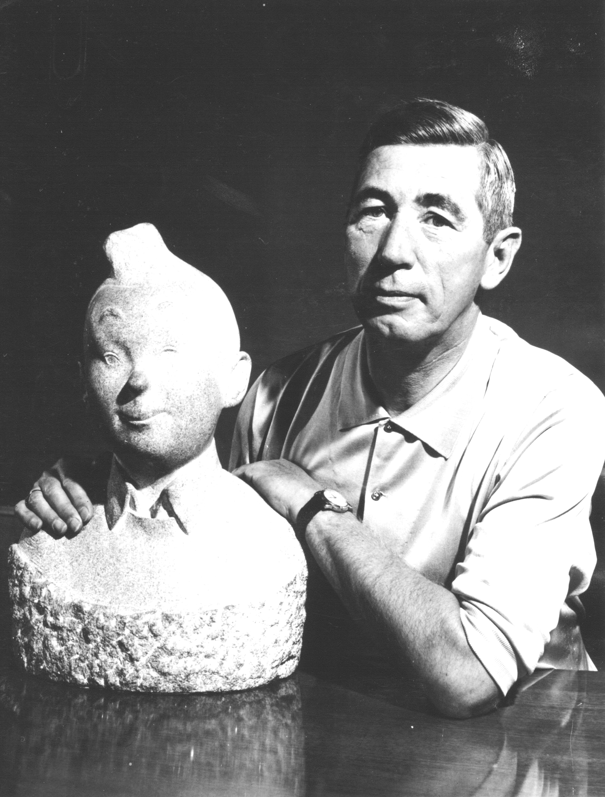 Which of the following comic strips is **not** Belgian?

 Lucky Luke  The Smurfs

 Astérix  Boule & Bill

1. What’s the name of Hergé’s early figure who is said to be

Tintin’s precursor, whom he looks alike already a lot?

 Zette  Flupke

 Jocko  Totor, le boy scout

1. Put in the right chronological order

Land of Black Gold / Red Rackham’s Treasure

The Alph-Art / King Ottokar’s Sceptre

1. Join the following first names, related to Belgian comics, with the right family name.

Cuthberth Peeters

Pierre Calculus

Benny Haddock

Frederik Culliford

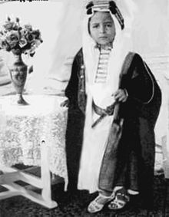 Archibald Breakiron

1. Internet did not exist at the time of Hergé. His work was based, among other sources, on pictures collected in newspapers or magazines. This picture of King Fayçal II from Irak inspired Hergé to invent the character of a naughty boy. What is this boy's name?

 Abdallah  Mohammed Ben Kalish Ezab

 Bab El Ehr  Youssouf Ben Moulfrid



**A cultural industry with particular customs**



1. Many comics became more famous on the screen than in their original printed version. Which of the following knew the height of success, thanks to a contract with Hannah Barbera, Warner Bros?

 The Smurfs  Gertie the Dinosaur

 Lucky Luke  Tintin

1. The yellow M by E.P. Jacobs has been parodied by a contemporary author. Which comic strip hero is introduced on this famous cover?

 Papa Smurf  Le Chat

 Spirou  Asterix

1. More than twenty different artists have drawn the comic strip hero Spirou over the years. As a matter of fact, the publishing house Dupuis is the owner of the copyrights on the character Spirou. These rights usually belong to the creator himself. What is the name of the artist who designed the new face of this character for the release of Spirou Magazine's number 501.

 Rob-Vel  Davine

 Jijé  Franquin

1. The gap between comics and film industry is forever getting smaller. Which of these animated adaptations cannot be seen in the museum?

 Persepolis  The Adventures of Tintin

 Marsupilami  Le Chat du Rabbin

1. Pieter De Poortere, the author of *Dickie*, likes to place his character into paintings he purchases on flea markets. Some of the paintings where Dickie has been hidden are well-known masterpieces. Within these four paintings from historical masters, which one has not been used by Pieter De Poortere?

□ Johannes Vermeer – The Music Lesson

□ Eugène Delacroix – Liberty Leading the People

□ Pieter Bruegel the Elder – The Peasant Wedding

□ Jean-François Millet –The Gleaners

**Various**



1. What is the name of the comic strip artist who has his own museum in our street?

 Marc Sleen  Gomer Goof

 Nero  Art Spiegelman

1. Thanks to several partnership opportunities with other great countries of comic strips, the Chinese Embassy in Belgium gave the Comics Art Museum a bronze statue of a comic strip character as a gift. What is the name of this character?

 Porcorosso  Masquerouge (The Red Mask)

 Son Goku  San Mao

1. One of the main difference between Thomson and Thompson is their name. But was is the other one?
2. Which of the following comic strip artist did not use the direct colouring process to create his covers?

Rosinski Vance

Malès  Berthet

1. From which Tintin album does the drawing underneath the broken step of the central staircase come? You can consult the albums in the reading room on the ground floor.
2. In which year Spirou was created? The answer to that question is neither to be found on small exhibition captions, nor in an exhibition text. On the contrary, the answer is written in very large letters!

**Thank you for your participation!**